Silver Club at The Captain Cook
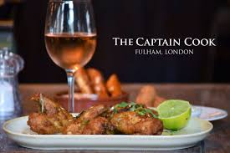
Discounted lunch and meeting opportunity for retired neighbours. The owners and staff at The Captain Cook welcome us to a tasty lunch for only £5 and the Fulham and Chelsea Women’s Institute members bake delicious cakes.
When: Every first Tuesday of the month between 12PM and 3PM
Where: The Captain Cook, 203-205 Dawes Road, London, SW6 7QY
Cost: £5 for a two course lunch, cake, soft drinks, tea or coffee
How to join: There are only 15 places and attendance needs to be pre-booked by contacting Fulham Good Neighbours on 020 7385 8850.

